Test Cases

Case 1: Invalid / non-formatted username

UI Response: Username not valid

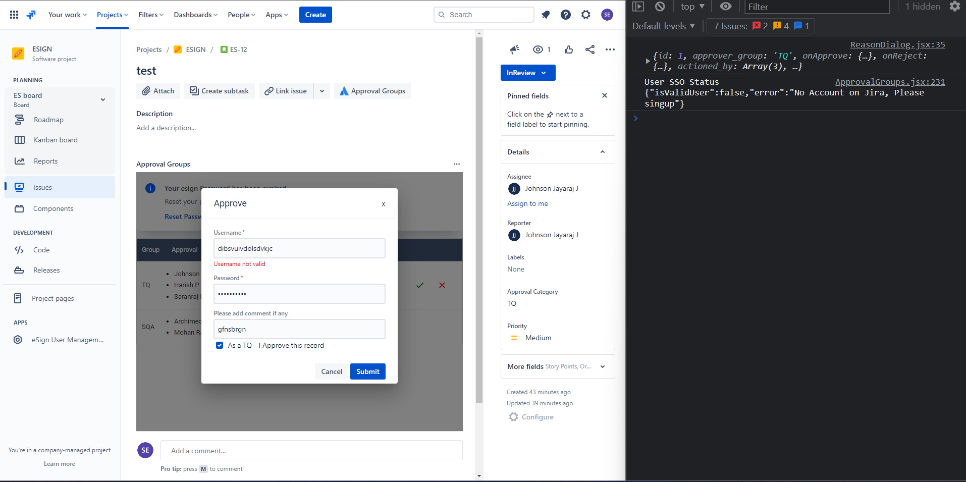

Case 2: Entered user’s account different from logged-in user’s account

UI Response: Please provide credentials for the logged-in user.

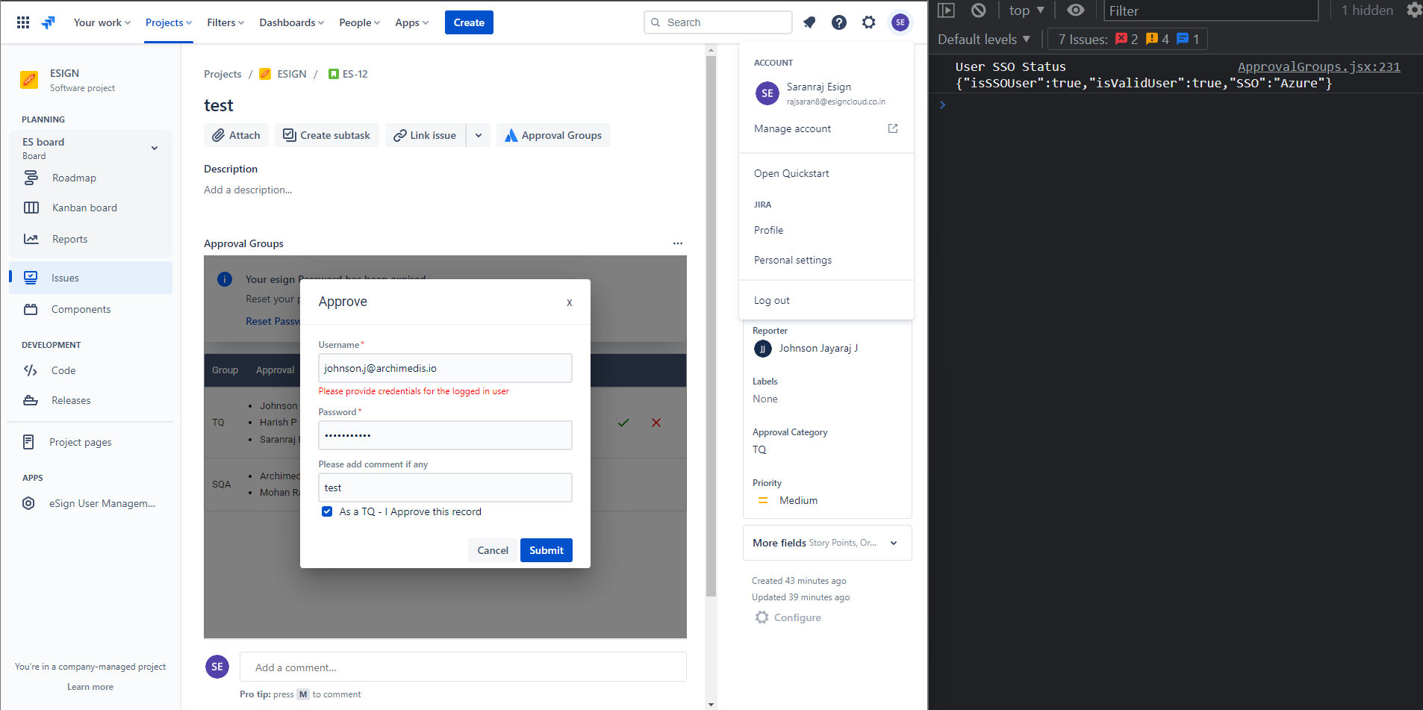

Case 3: Invalid credentials for the logged-in user.

UI Response: Invalid credentials provided

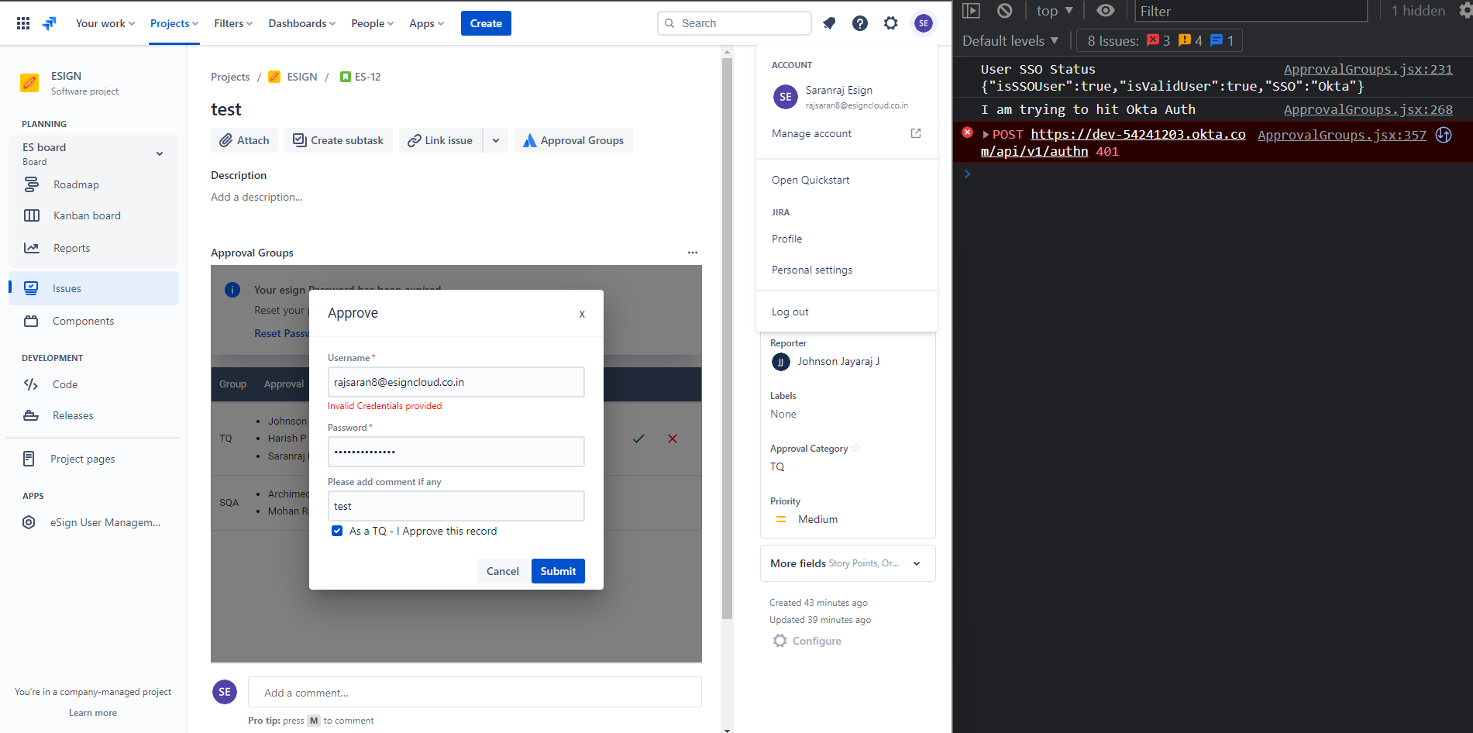

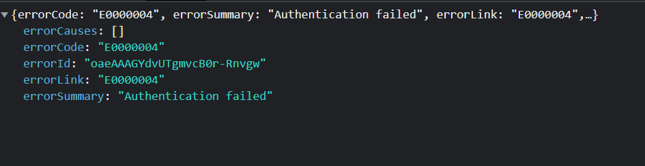

Case 4: Credentials for the logged-in user who is the reporter of the issue.

UI Response: Creator cannot be the reviewer 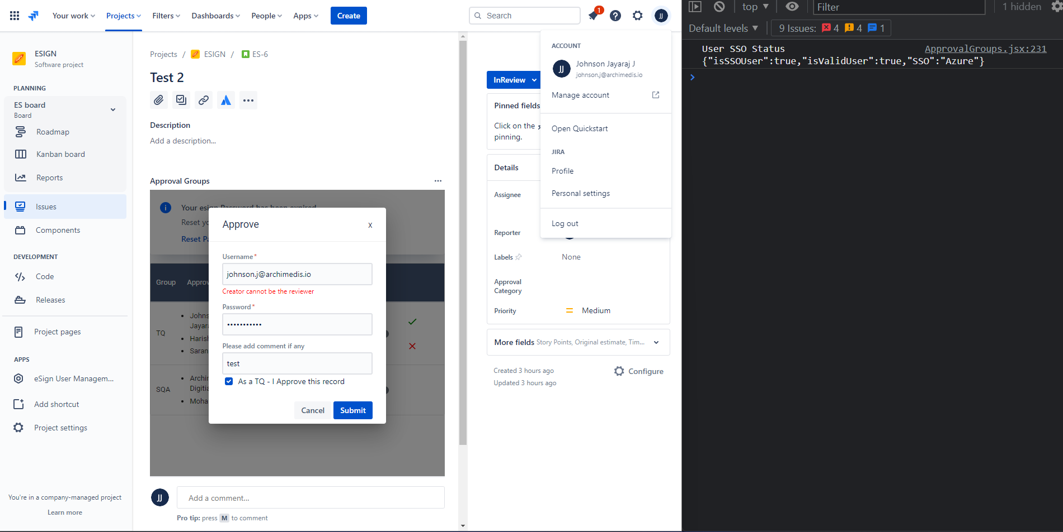

Case 5: Correct credentials for the logged-in user.

UI Response: Approved Ok

